|  |  |
| --- | --- |
| Project Title | Daily Transactions |
| Tools | Visual Studio code / jupyter notebook |
| Domain | Finance Analyst |
| Project Difficulties level | intermediate |

Dataset : Dataset is available in the given link. You can download it at your convenience.

[Click](https://drive.google.com/file/d/1GaU7epateQdLdltGoc-xnbO9LI6OFDOU/view?usp=sharing) [here](https://drive.google.com/file/d/1GaU7epateQdLdltGoc-xnbO9LI6OFDOU/view?usp=sharing) [to](https://drive.google.com/file/d/1GaU7epateQdLdltGoc-xnbO9LI6OFDOU/view?usp=sharing) [download](https://drive.google.com/file/d/1GaU7epateQdLdltGoc-xnbO9LI6OFDOU/view?usp=sharing) [data](https://drive.google.com/file/d/1GaU7epateQdLdltGoc-xnbO9LI6OFDOU/view?usp=sharing) [set](https://drive.google.com/file/d/1GaU7epateQdLdltGoc-xnbO9LI6OFDOU/view?usp=sharing)

# About Dataset

The "Daily Transactions" dataset contains information on dummy transactions made by an individual on a daily basis. The dataset includes data on the products that were purchased, the amount spent on each product, the date and time of each transaction, the payment mode of each transaction, and the source of each record (Expense/Income).

This dataset can be used to analyze purchasing behavior and money management, forecasting expenses, and optimizing savings and budgeting strategies. The dataset is well-suited for data analysis and machine learning applications,it can be used to train predictive models and make data-driven decisions.

**Column Descriptors**

* **Date:** The date and time when the transaction was made
* **Mode:** The payment mode used for the transaction
* **Category:** Each record is divided into a set of categories of transactions
* **Subcategory:** Categories are further broken down into Subcategories of transactions
* **Note:** A brief description of the transaction made
* **Amount:** The transactional amount
* **Income/Expense:** The indicator of each transaction representing either expense or income
* **Currency:** All transactions are recorded in official currency of India

## Example: You can get the basic idea how you can create a project from here

Sure! Let's outline a financial analyst project that involves working with a dataset of daily transactions. We'll include steps to clean the data, perform analysis, and generate a report with code examples in Python using popular libraries like Pandas, NumPy, Matplotlib, and Seaborn.

**1. Project Overview Objective:**

* Analyze daily financial transactions to identify trends, patterns, and insights.
* Generate a comprehensive report with visualizations.

### 2. Dataset Description

* **Date**: Date of the transaction.
* **Transaction_ID**: Unique identifier for each transaction.
* **Account_ID**: Unique identifier for the account.
* **Category**: Category of the transaction (e.g., Sales, Purchase, Salary).
* **Amount**: Amount of money involved in the transaction.
* **Type**: Type of transaction (Credit or Debit).

**3. Steps to Complete the Project**

### Step 1: Import Libraries and Load Data

|  |
| --- |
| import pandas as pd import numpy as np  import matplotlib.pyplot as plt import seaborn as sns |

# Load the dataset df = pd.read_csv('daily_transactions.csv')

# Display the first few rows of the dataset df.head()

### Step 2: Data Cleaning

* Handle missing values.
* Correct data types.
* Remove duplicates.

|  |
| --- |
| # Check for missing values  df.isnull().sum()  # Fill or drop missing values  df['Category'].fillna('Unknown', inplace=True)  df.dropna(subset=['Date', 'Transaction_ID', 'Amount'], inplace=True)  # Convert data types  df['Date'] = pd.to_datetime(df['Date']) df['Amount'] = df['Amount'].astype(float)  # Remove duplicates  df.drop_duplicates(inplace=True) |

# Verify data types df.dtypes

### Step 3: Exploratory Data Analysis (EDA)

* Summary statistics.
* Distribution of transaction amounts.
* Transaction counts by category and type.

|  |
| --- |
| # Summary statistics df.describe()  # Distribution of transaction amounts plt.figure(figsize=(10, 6))  sns.histplot(df['Amount'], bins=50, kde=True) plt.title('Distribution of Transaction Amounts') plt.xlabel('Amount') plt.ylabel('Frequency') plt.show()  # Transaction counts by category  plt.figure(figsize=(12, 6))  sns.countplot(data=df, x='Category', order=df['Category'].value_counts().index) plt.title('Transaction Counts by Category') |
| plt.xlabel('Category') plt.ylabel('Count') plt.xticks(rotation=45) plt.show()  # Transaction counts by type  plt.figure(figsize=(10, 6)) sns.countplot(data=df, x='Type') plt.title('Transaction Counts by Type') plt.xlabel('Type') plt.ylabel('Count') plt.show() |

### Step 4: Time Series Analysis

* Trend analysis.
* Monthly and daily trends.

|  |
| --- |
| # Resample data to monthly frequency monthly_data = df.resample('M', on='Date').sum()  plt.figure(figsize=(14, 7))  plt.plot(monthly_data.index, monthly_data['Amount'], marker='o') plt.title('Monthly Transaction Amounts') plt.xlabel('Month') plt.ylabel('Total Amount') |
| plt.grid(True) plt.show()  # Daily trends  daily_data = df.groupby(df['Date'].dt.date).sum()  plt.figure(figsize=(14, 7))  plt.plot(daily_data.index, daily_data['Amount'], marker='o') plt.title('Daily Transaction Amounts') plt.xlabel('Date') plt.ylabel('Total Amount') plt.grid(True) plt.show() |

### Step 5: Correlation Analysis

* Analyze the correlation between transaction categories and amounts.

|  |
| --- |
| # Create a pivot table for correlation analysis  pivot_table = df.pivot_table(index='Date', columns='Category', values='Amount', aggfunc='sum', fill_value=0)  # Calculate correlation matrix correlation_matrix = pivot_table.corr() |
| # Plot correlation heatmap plt.figure(figsize=(12, 8))  sns.heatmap(correlation_matrix, annot=True, cmap='coolwarm', linewidths=0.5) plt.title('Correlation Heatmap of Transaction Categories') plt.show() |

**Step 6: Generate Report**

* Summarize findings and visualizations.

**4. Report**

### Summary

The financial transactions dataset was analyzed to identify key trends and insights. The data cleaning process involved handling missing values, correcting data types, and removing duplicates. Exploratory Data Analysis (EDA) revealed the distribution of transaction amounts, transaction counts by category and type, and significant patterns over time. Time series analysis highlighted monthly and daily transaction trends.

Correlation analysis identified relationships between different transaction categories.

### Key Findings

* The distribution of transaction amounts showed a right-skewed pattern with most transactions clustered around lower values.
* Sales and Purchases were the most common transaction categories.
* Credit transactions were more frequent than Debit transactions.
* Monthly transaction trends revealed seasonal patterns with peaks in certain months.
* Correlation analysis indicated strong relationships between certain transaction categories.

### Visualizations

* Distribution of Transaction Amounts
* Transaction Counts by Category and Type
* Monthly and Daily Transaction Amounts
* Correlation Heatmap of Transaction Categories

This project provides valuable insights into daily financial transactions, helping to inform decision-making and strategic planning.

Would you like more details on any specific part of the project or any additional analysis?

## Example: You can get the basic idea how you can create a project from here

### Sample code with output

|  |
| --- |
| *# This Python 3 environment comes with many helpful analytics libraries installed*  *# It is defined by the kaggle/python Docker image:*  *https://github.com/kaggle/docker-python*  *# For example, here's several helpful packages to load*  import numpy as np *# linear algebra* import pandas as pd *# data processing, CSV file I/O (e.g. pd.read_csv)*  *# Input data files are available in the read-only "../input/" directory*  *# For example, running this (by clicking run or pressing Shift+Enter) will list all files under the input directory*  import os for dirname, _, filenames **in** os.walk('/kaggle/input'):  for filename **in** filenames:  print(os.path.join(dirname, filename))  *# You can write up to 20GB to the current directory*  *(/kaggle/working/) that gets preserved as output when you create* |

*a*

*version*

*using*

*"Save*

*&*

*Run*

*All"*

*#*

*You*

*can*

*also*

*write*

*temporary*

*files*

*to*

*/kaggle/temp/,*

*but*

*they*

*won't*

*be*

*saved*

*outside*

*of*

*the*

*current*

*session*

/kaggle/input/daily-transactions-dataset/Daily

Household

Transactions.csv

In

[2]:

import

seaborn

as

sns

import

matplotlib.pyplot

as

plt

In

[3]:

df

=

pd

.

read_csv(

"/kaggle/input/daily-transactions-dataset/Daily

Household

Transactions.csv"

)

In

[4]:

df

.

head()

*#check*

*the*

*first*

*5*

*rows*

*of*

*the*

*dataset*

Out[4]:

|  |  |  |  |  |  |  |  |  |  |  |  |  |  |  |  |  |  |  |  |  |  |  |  |  |  |  |  |  |  |  |  |  |  |  |  |  |  |  |  |  |  |  |  |  |  |  |  |  |  |  |  |  |  |  |
| --- | --- | --- | --- | --- | --- | --- | --- | --- | --- | --- | --- | --- | --- | --- | --- | --- | --- | --- | --- | --- | --- | --- | --- | --- | --- | --- | --- | --- | --- | --- | --- | --- | --- | --- | --- | --- | --- | --- | --- | --- | --- | --- | --- | --- | --- | --- | --- | --- | --- | --- | --- | --- | --- | --- |
| |  |  |  |  |  |  |  |  |  | | --- | --- | --- | --- | --- | --- | --- | --- | --- | |  | Date | Mode | Categ ory | Subcatego  ry | Note | Am ou  nt | Income /Expen se | Cur ren cy | | 0 | 20/09/20  18  12:04:08 | Cash | Trans  portati  on | Train | 2 Place 5 to  Place 0 | 30.  0 | Expens e | INR | | 1 | 20/09/20  18  12:03:15 | Cash | Food | snacks | Idli medu Vada mix 2  plates | 60.  0 | Expens e | INR | | 2 | 19/09/20  18 | Saving Bank account 1 | subscr iption | Netflix | 1 month  subscription | 19 9.0 | Expens e | INR | | 3 | 17/09/20  18  23:41:17 | Saving Bank account 1 | subscr iption | Mobile  Service  Provider | Data booster pack | 19.  0 | Expens e | INR | | 4 | 16/09/20  18 | Cash | Festiv | Ganesh | Ganesh idol | 25 | Expens | INR | |

|  |  |  |  |  |  |  |  |  |  |
| --- | --- | --- | --- | --- | --- | --- | --- | --- | --- |
| |  |  |  |  |  |  |  |  |  | | --- | --- | --- | --- | --- | --- | --- | --- | --- | |  | 17:15:08 |  | als | Pujan |  | 1.0 | e |  |   In [5]:  df.shape *#get the number of rows and columns in the dataset*  Out[5]:  (2461, 8)  In [6]: df.info()  <class 'pandas.core.frame.DataFrame'>  RangeIndex: 2461 entries, 0 to 2460 Data columns (total 8 columns):  # Column Non-Null Count Dtype  --- ------ -------------- ----0 Date 2461 non-null object   1. Mode 2461 non-null object 2. Category 2461 non-null object 3. Subcategory 1826 non-null object 4. Note 1940 non-null object 5. Amount 2461 non-null float64 6. Income/Expense 2461 non-null object |

7

Currency

2461

non-null

object

dtypes:

float64(1),

object(7)

memory

usage:

153.9+

KB

In

[7]:

df

.

isnull()

.

sum()

*#get*

*the*

*null*

*values*

Out[7]:

Date

0

Mode

0

Category

0

Subcategory

635

Note

521

Amount

0

Income/Expense

0

Currency

0

dtype:

int64

In

[8]:

df[

"Mode"

]

.

value_counts()

Out[8]:

|  |
| --- |
| Mode  Saving Bank account 1 1223  Cash 1046  Credit Card 162  Equity Mutual Fund B 11  Share Market Trading 5  Saving Bank account 2 5  Recurring Deposit 3  Debit Card 2  Equity Mutual Fund C 1  Equity Mutual Fund A 1  Equity Mutual Fund D 1  Fixed Deposit 1  Name: count, dtype: int64  In [9]: plt.figure(figsize = (12,8)) sns.countplot(data = df, x = "Mode", order = df["Mode"].value_counts().iloc[:3].index) plt.show() |

In

[10]:

df[

"Category"

]

.

value_counts()

Out[10]:

Category

Food

907

Transportation

307

Household

176

subscription

143

Other

126

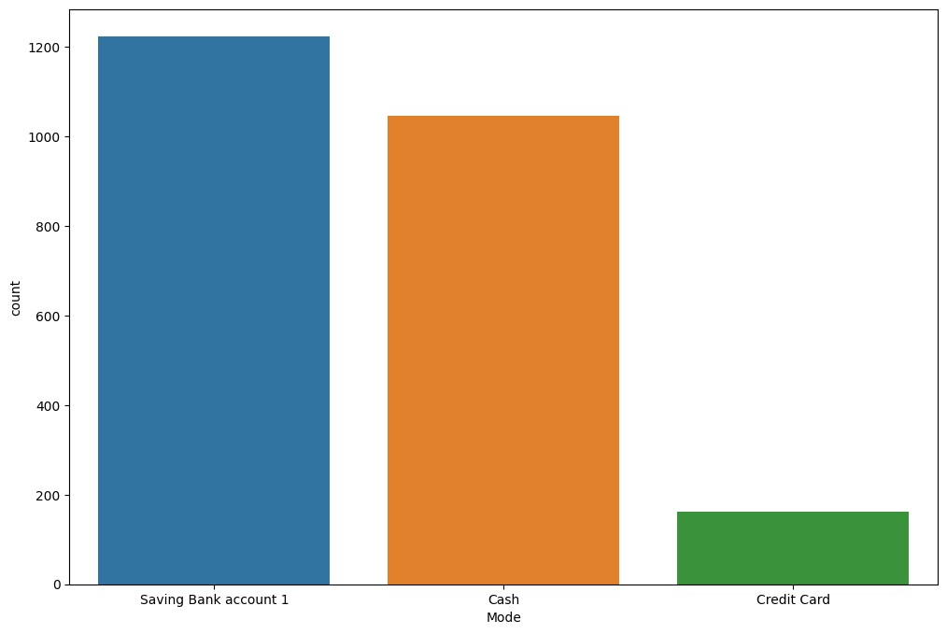

|  |  |
| --- | --- |
| Investment | 103 |
| Health | 94 |
| Family | 71 |
| Recurring Deposit | 47 |
| Apparel | 47 |
| Money transfer | 43 |
| Salary | 43 |
| Gift | 30 |
| Public Provident Fund | 29 |
| Equity Mutual Fund E | 22 |
| Beauty | 22 |
| Gpay Reward | 21 |
| Education | 18 |
| maid | 17 |
| Saving Bank account 1 | 17 |
| Festivals | 16 |
| Equity Mutual Fund A | 14 |
| Equity Mutual Fund F | 13 |
| Interest | 12 |
| Dividend earned on Shares | 12 |
| Culture | 11 |
| Small cap fund 1 | 10 |
| Small Cap fund 2 | 10 |
| Share Market | 8 |
| Maturity amount | 7 |

Life Insurance 7

Bonus 6

Equity Mutual Fund C 6

Petty cash 6

Tourism 5

Cook 4

Rent 4

Grooming 4 water (jar /tanker) 3 Saving Bank account 2 3 garbage disposal 2 scrap 2

Fixed Deposit 2

Self-development 2

Amazon pay cashback 2

Documents 2

Tax refund 2

Equity Mutual Fund B 1

Equity Mutual Fund D 1

Social Life 1

Name: count, dtype: int64

In [11]:

sns.countplot(data = df, x = "Category", order = df["Category"].value_counts().iloc[:5].index);

In

[12]:

df[

"Subcategory"

]

.

unique()

Out[12]:

array(['Train',

'snacks',

'Netflix',

'Mobile

Service

Provider',

'Ganesh

Pujan',

'Tata

Sky',

'auto',

nan,

'Grocery',

'Lunch',

'Milk',

'Pocket

money',

'Laundry',

'breakfast',

'Dinner',

'Sweets',

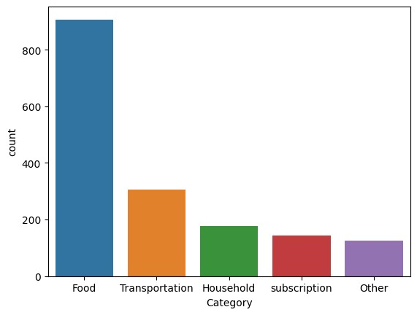

'Kirana', 'Ice cream', 'curd', 'Biscuits', 'Rajgira ladu',

'Navratri', 'train', 'Tea', 'flour mill', 'Appliances',

'home decor', 'grooming', 'Health', 'Clothing',

'clothes', 'Home',

'chocolate', 'Medicine', 'Eating out', 'Movie',

'vegetables',

'fruits', 'Potato', 'Onions', 'Taxi', 'Hardware',

'Eggs', 'Bread',

'Petrol', 'Hospital', 'Mahanagar Gas', 'Lab Tests',

'Bus',

'Travels', 'Kitchen', 'Footwear', 'Entry Fees',

'gadgets',

'Accessories', 'misc', 'Stationary', 'Newspaper',

'Toiletries',

'Bike', 'beverage', 'makeup', 'Books', 'Holi', 'Courier',

'Leisure', 'Updation', 'Amazon Prime', 'Edtech Course',

'Hotstar',

'Diwali', 'Wifi Internet Service', 'Trip', 'Furniture',

'Water',

'Cable TV', 'medicine', 'Mutual fund', 'Public Provident Fund',

'ropeway', 'RD', 'LIC', 'Saloon', 'gift',

'Rakshabandhan',

|  |
| --- |
| 'exam fee', 'Kindle unlimited', 'OTT Platform', 'School supplies',  'Audible', 'Makeup'], dtype=object)  In [13]: plt.figure(figsize = (12,8)) sns.countplot(data = df, x = "Subcategory", order = df["Subcategory"].value_counts().iloc[:10].index) plt.xticks(rotation = 90) plt.show() |

In

[14]:

sns

.

countplot(data

=

df,

x

=

"Income/Expense"

)

;

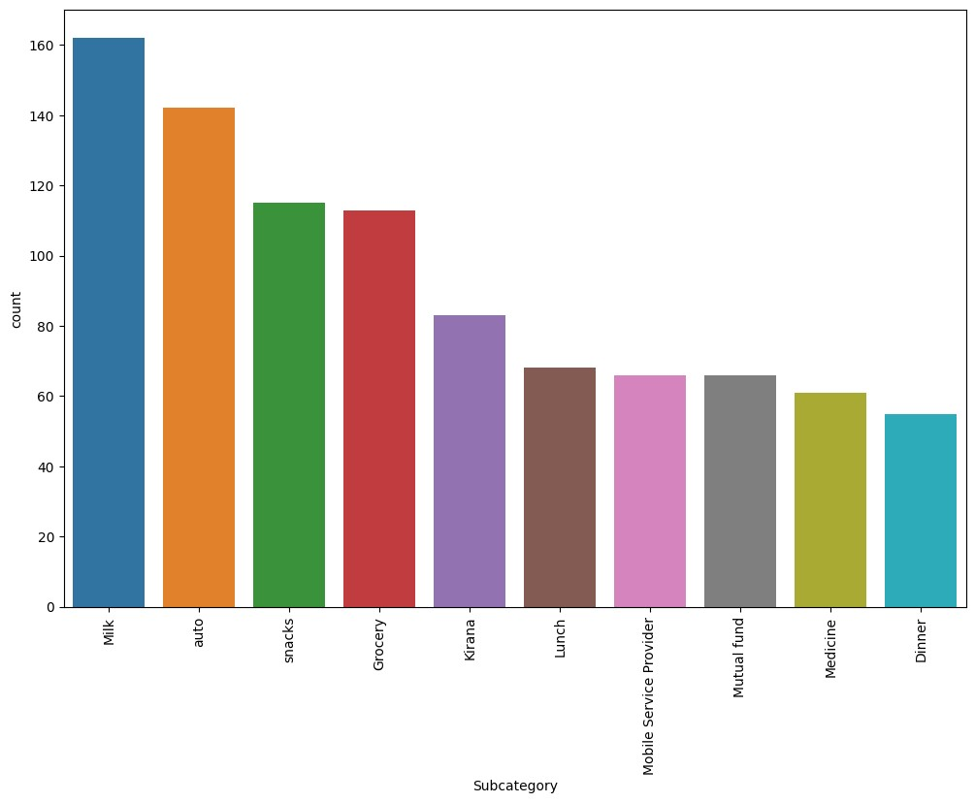

In

[15]:

df[

"Note"

]

.

nunique()

Out[15]:

1057

In

[16]:

df[

"Currency"

]

.

value_counts()

Out[16]:

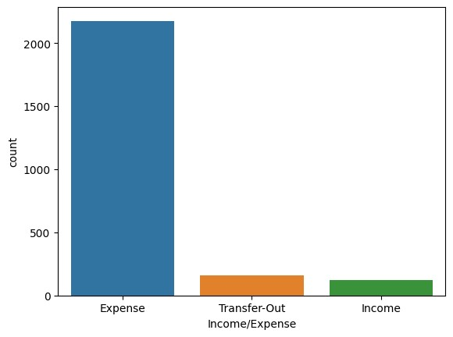

Currency

INR

2461

Name:

count,

dtype:

int64

In

[17]:

plt

.

figure(figsize

=

(

12

,

8

))

sns

.

boxplot(data

=

df,

x

=

"Amount"

,

y

=

"Category"

,

order

=

df[

"Category"

]

.

value_counts()

.

iloc[:

5

]

.

index)

plt

.

show()

In

[18]:

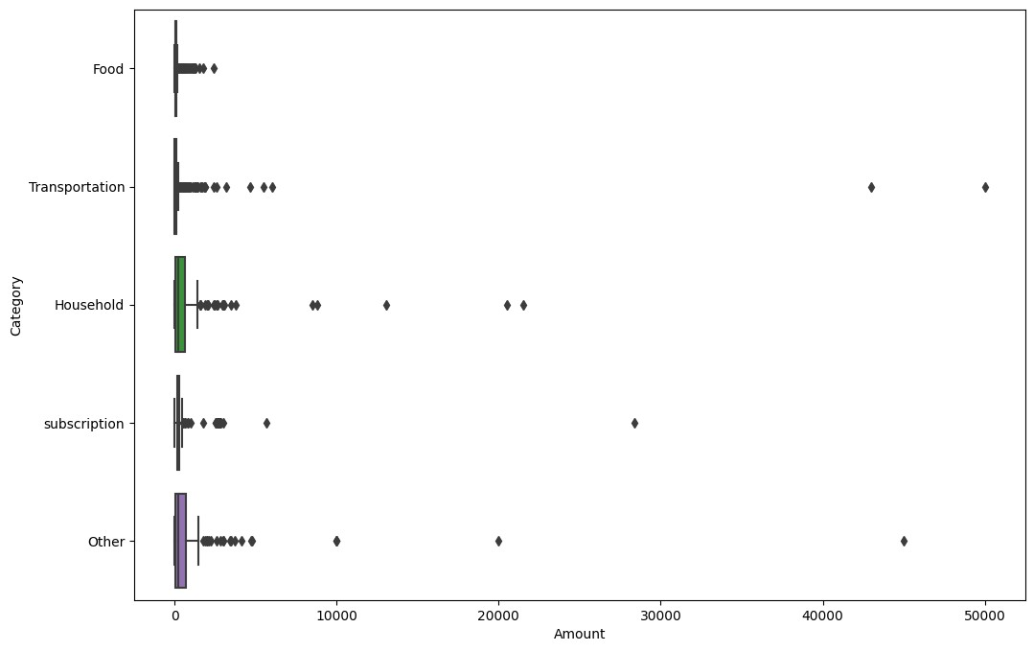

plt

.

figure(figsize

=

(

12

,

8

))

sns

.

boxplot(data

=

df,

x

=

"Amount"

,

y

=

"Subcategory"

,

order

=

df[

"Subcategory"

]

.

value_counts()

.

iloc[:

10

]

.

index,

)

plt

.

show()

In

[19]:

sns

.

boxplot(data

=

df,

x

=

"Amount"

,

y

=

"Income/Expense"

;

)

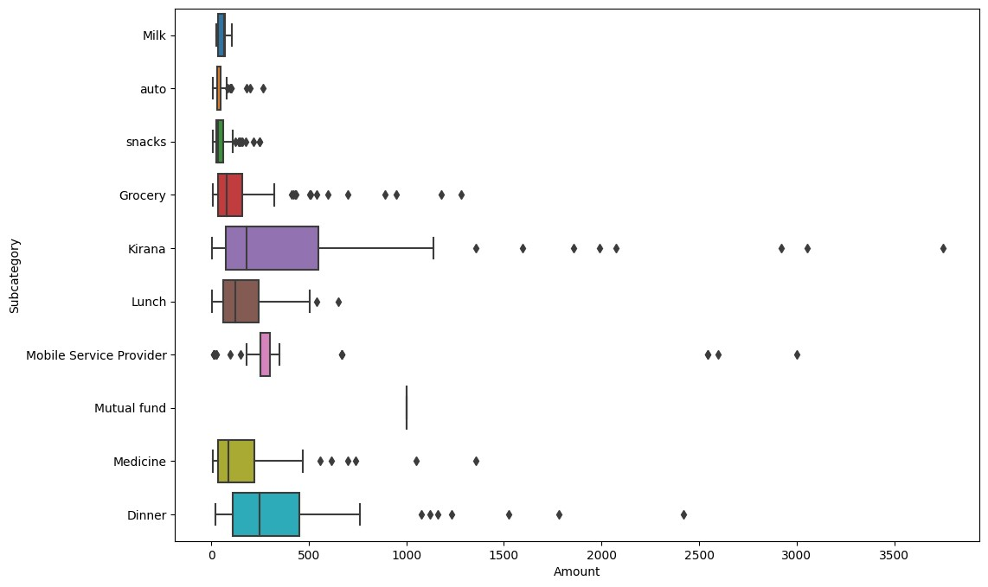

In

[20]:

sns

.

scatterplot(data

=

df,x

=

"Income/Expense"

,

y

=

"Mode"

,);

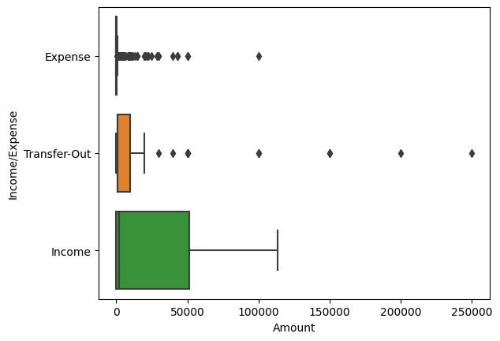

In

[

]:

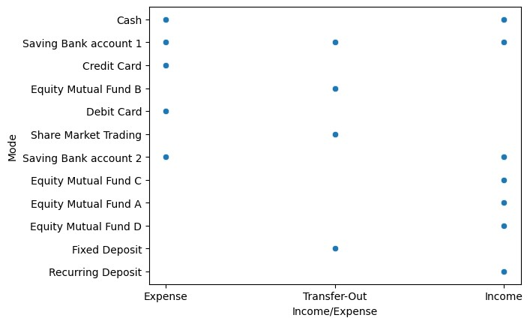

[**Reference**](https://github.com/SouRitra01/Exploratory-Data-Analysis-EDA-in-Banking-Python-Project-/blob/main/Proj1_EDA_Pandas_Banking%20(1).ipynb)[**link**](https://github.com/SouRitra01/Exploratory-Data-Analysis-EDA-in-Banking-Python-Project-/blob/main/Proj1_EDA_Pandas_Banking%20(1).ipynb)